**Author:**

Harika adivanne

Class id: 02

**Objective:**

The Key objective is to focus on all the python basics and to execute better code with zero defects and reach the expected output.

**Features:**

1. Proper indentation

2. Easy understanding

3. Loops

4. Usage of inbuilt keywords

5. Arithmetic operations

**Configuration:**

IDE: PycharmCE2017

LANGUAGE: Python 3

Input/output:

**INPUT/OUTPUT:**

1) For any web application login, the user password needs to be validated against database rules. For My UMKC web application following are the criteria for valid password: a)The password length should be in range 6-16 characters)Should have at least one numberc)Should have atleast one special character in [$@!*]d)Should have at least one lowercase and atleast one uppercase character Use loops to write a python program for the above scenario.

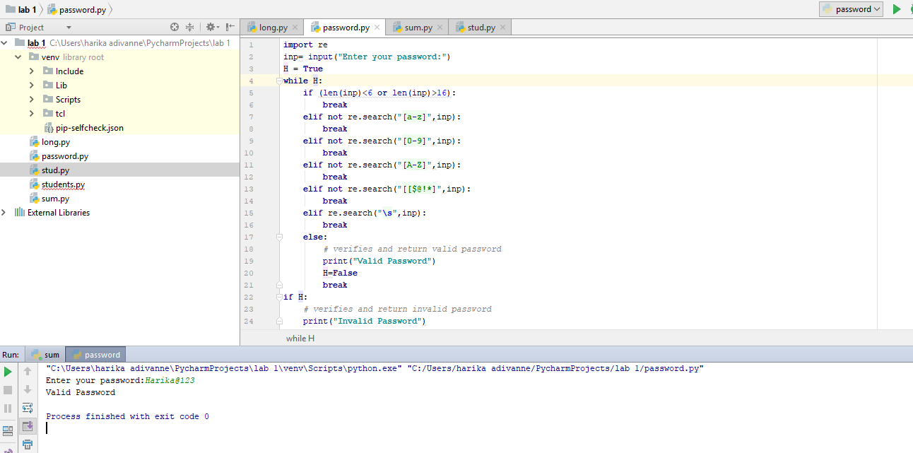

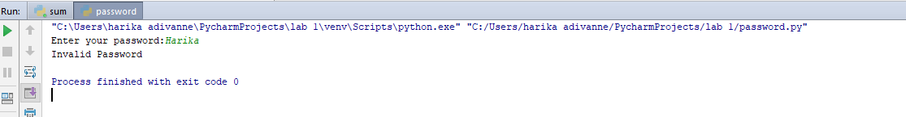

**Implementation:**

For the given conditions the above code is implemented as follows.

*Initially imported regular expressions and declared a variable for the output, for the given conditions i have used while loop where it will check all the condition and returns as valid password for the variable true and else it will break the loop and print as invalid password.

**2) Write a Python function that accepts a sentence of words from user and display the following: a) Middle word b) Longest word in the sentence c) Reverse all the words in sentence**

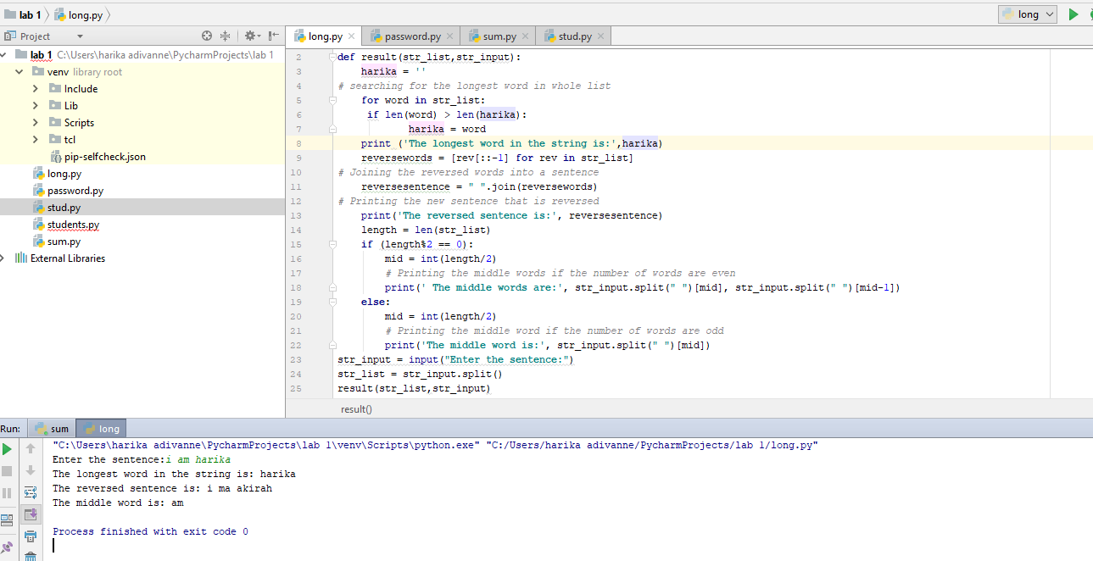

**Implementation:**

*Here i have used the longest word and also to print the reverse word

*In that i have searched the longest word in the given input list by initializing the object (harika = '') and compared every word among the list it prints the longest word

*By using string i printed the reverse of words (rev [::-1]) and joined those words to form a sentence

*Finally to find the middle word of the sentence by using the If condition where it divides by zero ((length%2 == 0)), int (length/2) and based on results it will split the words and print the word.

**3) Given a list of n number, write a Python program to find triplets in the list which gives the sum of zero.**

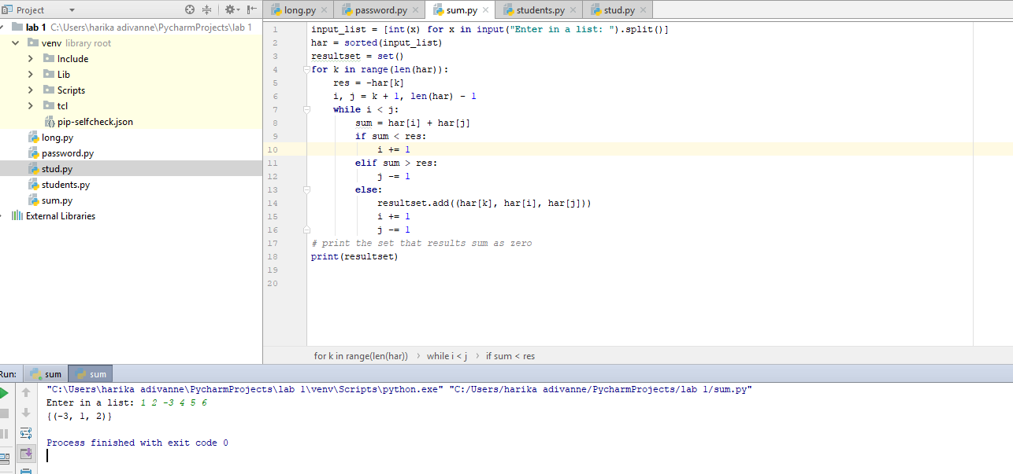

**Implementation:**

*Take the list for input numbers and sort the corresponding list

*create on empty set and run the for loop for variables sum i, j, k

*While loop will be executed for comparison of numbers in the range of or input

*set of numbers which sum results and stores in the set (resultset) and prints the set.

**4) Consider the following scenario. You have a list of students who are attending class “Python” and another list of students who are attending class “Web Application”. Find the list of students who are attending both the classes. Also find the list of students who are not common in both the classes. Print it.**

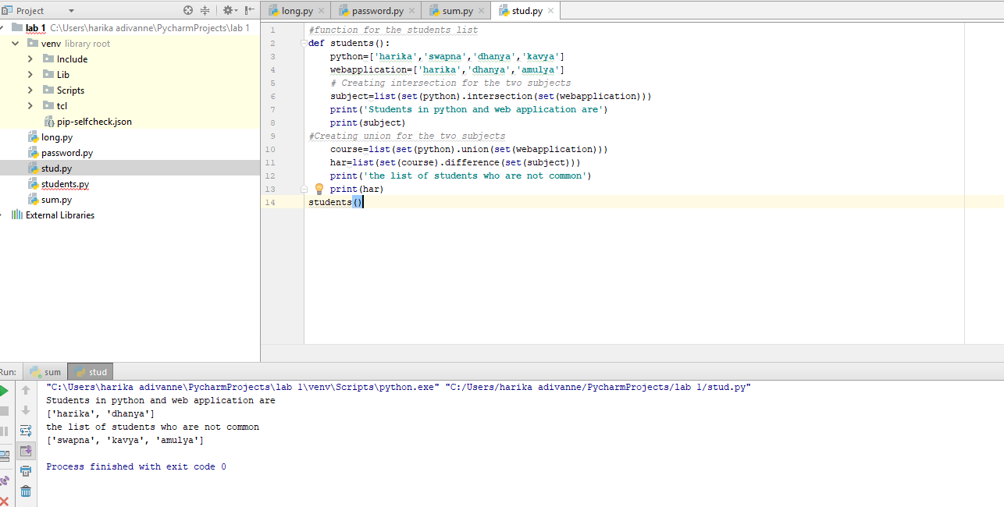

**Implementation:**

*Created a function for students an also two lists for two subjects

*Created intersection and union for the subjects and list of students

*Print the results

**Deployment:**

Code has executed in IDE pycharm environment using Python 3 language by creating folder which has all the pycharm files with .py extension. Codes are executed n .py files and the results are shown in console. If it is executed with code 0 then the code has no errors or else it will show the module errors.

**Limitation:**

*Version compatibility

*speed

**References:**

<https://www.learnpython.org/>

<https://www.geeksforgeeks.org/python/>